Driver Program : ZHMS_DRIVER_SF_01
Smartforms Name : ZHMS_SF_PRESCRIPTION / ZHMS_SF_PRESCRIPTION
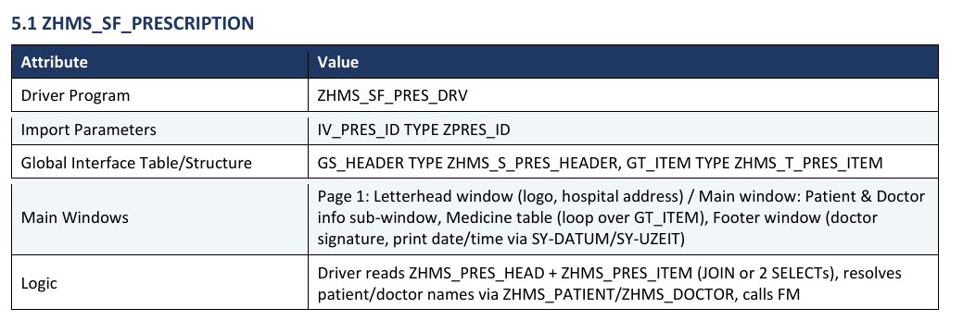
Driver Program : ZHMS_DRIVER_SF_01

*&---------------------------------------------------------------------*
*& Report ZHMS_DRIVER_SF_01
*&---------------------------------------------------------------------*
*&
*&---------------------------------------------------------------------*
REPORT zhms_driver_sf_01.
TABLES :zhms_patient, zhms_doctor, zhms_medical, zhms_pres_head, zhms_pres_item.
DATA : it_patient TYPE TABLE OF zstr_pat_01.
DATA : wa_patient TYPE zstr_pat_01.
DATA : it_doc TYPE TABLE OF zstr_doctor_01.
DATA : wa_doc TYPE zstr_doctor_01.
DATA : it_med TYPE TABLE OF zstr_medical_02.
DATA : wa_med TYPE zstr_medical_02.
DATA : it_pres TYPE TABLE OF zstr_pres_01.
DATA : wa_pres TYPE zstr_pres_01.
DATA : lv_date TYPE char20.
DATA : lv_time TYPE char20.
DATA : lv_dept TYPE char50.
DATA : lv_day TYPE c LENGTH 2.
DATA : lv_month TYPE c LENGTH 3.
DATA : lv_year TYPE c LENGTH 4.
DATA : lv_hour TYPE c LENGTH 2.
DATA : lv_min TYPE c LENGTH 2.
DATA : lv_sec TYPE c LENGTH 2.
DATA : lv_ampm TYPE c LENGTH 2.
DATA : lv_hour_int TYPE i.
DATA : lv_fm_name TYPE rs38l_fnam.
DATA : wa_ctrl TYPE ssfctrlop.
DATA : wa_outopt TYPE ssfcompop.
DATA : lx_exc TYPE REF TO cx_root.
"otf t pdf convert
DATA : it_otf TYPE ssfcrescl.
DATA : it_otf_data TYPE TABLE OF itcoo.
DATA : it_pdf_tab TYPE TABLE OF tline.
DATA : it_bin_tab TYPE TABLE OF sdokcntasc.
DATA : lv_pdf_size TYPE i.
DATA : lv_file_name TYPE string.
DATA : lv_path TYPE string.
DATA : lv_fullpath TYPE string.
DATA : lv_user_action TYPE i.
SELECTION-SCREEN : BEGIN OF BLOCK b1 WITH FRAME TITLE TEXT-000.
SELECT-OPTIONS : s_pat FOR zhms_patient-patient_id
NO-EXTENSION.
SELECT-OPTIONS : s_doc FOR zhms_doctor-doctor_id
NO-EXTENSION.
SELECTION-SCREEN : END OF BLOCK b1.
START-OF-SELECTION.
PERFORM fetch_data.
PERFORM call_smartform.
*&------------------------------------------------------------------*
*& FORM FETCH_DATA
*&------------------------------------------------------------------*
FORM fetch_data.
SELECT
patient_name,
patient_id,
dob,
address,
gender
INTO TABLE @it_patient
FROM zhms_patient
WHERE patient_id IN @s_pat.
IF it_patient IS INITIAL.
MESSAGE 'No patient found' TYPE 'I'.
LEAVE LIST-PROCESSING.
ENDIF.
READ TABLE it_patient INTO wa_patient INDEX 1.
SELECT doctor_id,
doctor_name,
specialization,
mobile_no,
address
INTO TABLE @it_doc
FROM zhms_doctor
WHERE doctor_id IN @s_doc.
READ TABLE it_doc INTO wa_doc INDEX 1.
SELECT c~medical_id,
c~patient_id,
c~doctor_id,
c~diagnosis,
c~treatment
INTO TABLE @it_med
FROM zhms_medical AS c
INNER JOIN zhms_patient AS a
ON a~patient_id = c~patient_id
INNER JOIN zhms_doctor AS b
ON b~doctor_id = c~doctor_id
WHERE a~patient_id IN @s_pat
AND b~doctor_id IN @s_doc.
SELECT p~pres_id,
i~item_no,
i~medicine_name,
i~med_quantity,
i~dosage,
i~dosage_days
INTO TABLE @it_pres
FROM zhms_pres_head AS p
INNER JOIN zhms_pres_item AS i
ON p~pres_id = i~pres_id
WHERE p~patient_id IN @s_pat
AND p~doctor_id IN @s_doc.
ENDFORM.
FORM call_smartform.
wa_ctrl-no_dialog = 'X'.
wa_ctrl-preview = ' '.
wa_ctrl-getotf = 'X'. "<<< IMPORTANT: get OTF instead of print
wa_outopt-tddest = 'LOCL'. "<<< dummy/local, not printer
wa_outopt-tdnoprev = 'X'.
*--- Step 3: Call SmartForm and capture OTF output
CALL FUNCTION '/1BCDWB/SF00000662'
EXPORTING
control_parameters = wa_ctrl
output_options = wa_outopt
wa_pat = wa_patient
wa_doctor = wa_doc
wa_medical = wa_med
lv_date = lv_date
lv_time = lv_time
lv_dept = lv_dept
IMPORTING
job_output_info = it_otf "<<< captures OTF data
TABLES
it_hms = it_pres
it_medical = it_med
EXCEPTIONS
formatting_error = 1
internal_error = 2
send_error = 3
user_canceled = 4
OTHERS = 5.
IF sy-subrc <> 0.
MESSAGE 'Error generating SmartForm output' TYPE 'E'.
RETURN.
ENDIF.
it_otf_data = it_otf-otfdata.
PERFORM convert_otf_to_pdf.
PERFORM download_pdf_to_local.
ENDFORM.
FORM convert_otf_to_pdf.
CALL FUNCTION 'CONVERT_OTF'
EXPORTING
format = 'PDF'
max_linewidth = 132
IMPORTING
bin_filesize = lv_pdf_size
TABLES
otf = it_otf_data
lines = it_pdf_tab
EXCEPTIONS
err_max_linewidth = 1
err_format = 2
err_conv_not_possible = 3
err_bad_otf = 4
OTHERS = 5.
IF sy-subrc <> 0.
MESSAGE 'Error converting OTF to PDF' TYPE 'E'.
RETURN.
ENDIF.
CALL FUNCTION 'SX_TABLE_LINE_WIDTH_CHANGE'
TABLES
content_in = it_pdf_tab
content_out = it_bin_tab.
ENDFORM.
FORM download_pdf_to_local.
* DATA(lo_frontend) = cl_gui_frontend_services=>zif_lvc_frontend~get_instance( ).
*--- Let user choose save location
cl_gui_frontend_services=>file_save_dialog(
EXPORTING
window_title = 'Save Patient Prescription PDF'
default_extension = 'pdf'
default_file_name = |PRESCRIPTION_{ wa_patient-patient_id }.pdf|
file_filter = 'PDF Files (*.pdf)|*.pdf|'
CHANGING
filename = lv_file_name
path = lv_path
fullpath = lv_fullpath
user_action = lv_user_action
EXCEPTIONS
cntl_error = 1
error_no_gui = 2
not_supported_by_gui = 3
OTHERS = 4 ).
IF sy-subrc <> 0 OR lv_user_action = cl_gui_frontend_services=>action_cancel.
MESSAGE 'Download cancelled' TYPE 'I'.
RETURN.
ENDIF.
*--- Perform actual download to local PC
cl_gui_frontend_services=>gui_download(
EXPORTING
bin_filesize = lv_pdf_size
filename = lv_fullpath
filetype = 'BIN'
CHANGING
data_tab = it_bin_tab
EXCEPTIONS
file_write_error = 1
no_batch = 2
gui_refuse_filetransfer = 3
invalid_type = 4
no_authority = 5
unknown_error = 6
header_not_allowed = 7
separator_not_allowed = 8
filesize_not_allowed = 9
header_too_long = 10
dp_error_create = 11
dp_error_send = 12
dp_error_write = 13
unknown_dp_error = 14
access_denied = 15
dp_out_of_memory = 16
disk_full = 17
dp_timeout = 18
file_not_found = 19
dataprovider_exception = 20
control_flush_error = 21
not_supported_by_gui = 22
error_no_gui = 23
OTHERS = 24 ).
IF sy-subrc = 0.
MESSAGE 'PDF downloaded successfully' TYPE 'S'.
ELSE.
MESSAGE 'Error downloading PDF' TYPE 'E'.
ENDIF.
ENDFORM.

